**055639 - Solar and Biomass Power Generation**

Rana Mahmoud Fadlmemula Ahmed - 10888916

Alessandro Borghesi - 10737923  
Matteo Frigerio - 10725934  
Seyed Mohammad Miri Joibary - 10884839

**Preliminary design and techno-economic assessment of a stand-alone PV plant with battery energy storage**

Table of Contents

Introduction 1

Site description 1

Electrical Loads 2

Appliances 2

Load Curves 3

Plant Design 5

System components 5

PV Panels 5

Inverter 5

Battery 6

Design analysis 6

Methodology adopted for the design optimization 7

BESS Operating Strategy 8

Results 9

Most critical week performance 12

Detailed design of the optimal configuration 13

DC side 13

AC side 13

Inverter matching 15

Battery – Inverter matching 16

Life Cycle Assessment 17

PV field’s carbon footprint 17

Battery Energy Storage System’s carbon footprint 18

Carbon intensity 19

Life Cycle Emissions 19

Conclusions 20

References 21

List of Figures, Tables and Charts 22

# Introduction

The aim of this report is the preliminary design and techno-economic assessment of a stand-alone PV plant with battery energy storage located in Juybar, Iran.  
The city is located in the province of Mazandaran, approximately 12 km south of the Caspian Sea’s shore.

The following analysis will be carried out considering the PV plant and battery energy storage to be installed and commence operation on January 1st, 2024.

## Site description

The stand-alone PV plant with battery and energy storage in this report will be designed for a residential application and will be installed on the chosen building’s rooftop.

Table 1: *Site location and rooftop characteristics*

s

S

|  |  |  |
| --- | --- | --- |
| **Site Location** | | |
| $$Latitude$$ | $$36.645216$$ | $$°N$$ |
| $$Longitude$$ | $$52.906816$$ | $$°E$$ |
| **Rooftop Characteristics (Southern Pitch)** | | |
| $$Width$$ | $$15$$ | $$m$$ |
| $$Length$$ | $$7.5$$ | $$m$$ |
| $$Heigth$$ | $$1$$ | $$m$$ |
| $$Area$$ | $$113.5$$ | $$m²$$ |
| $$Roof Tilt angle$$ | $$7.6$$ | $$°$$ |
| $$Azimuth angle$$ | $$10$$ | $$°$$ |

The selected building is a house located in the northern area of Juybar, Iran, at coordinates 36.645216° N, 52.906816° E. Being said location situated in the Northern Hemisphere, the PV modules should be ideally installed facing South with, if possible, a null azimuth angle.  
The house has a double pitched roof, with one of the two sides facing South with an azimuth angle of about 10° and a surface of 113.5 m² with a tilt angle of 7.6°. As this situation is close to being ideal, said side of the rooftop will be considered for the PV modules’ installation.

The building’s main sources of consumption are two living rooms, a kitchen, two bedrooms, two bathrooms and a shower room.

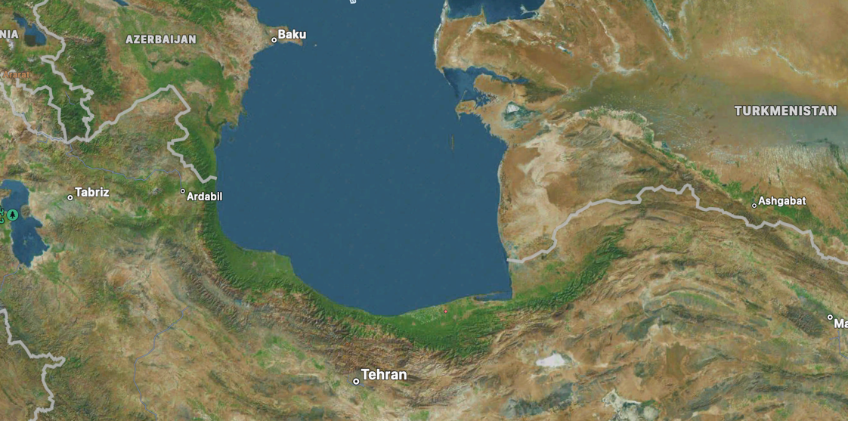

Figure 1  
*Project’s location on the map*

# Electrical Loads

## Appliances

Appliances present in the house and their consumptions are reported below as provided by the owner.

|  |  |  |
| --- | --- | --- |
| **Appliance type** | **Number of appliances per type** | **Rated Power [W]** |
| **Living Room 1** | | |
| LED Lights | 12 | 30 |
| TV | 1 | 60 |
| Air Conditioning | 1 | 1700 |
| **Living Room 2** | | |
| LED Lights | 8 | 30 |
| Wireless Router | 1 | 15 |
| **Kitchen** | | |
| LED Lights | 5 | 30 |
| Refrigerator | 1 | 200 |
| Freezer | 1 | 50 |
| Washing Machine | 1 | 500 |
| Oven | 1 | 1500 |
| Extractor Fan | 1 | 12 |
| **Bedroom 1** | | |
| LED Lights | 2 | 30 |
| TV | 1 | 60 |
| Iron | 1 | 1000 |
| Satellite Dish | 1 | 30 |
| **Bedroom 2** | | |
| LED Lights | 3 | 30 |
| **Bathroom 1** | | |
| Led Lights | 1 | 30 |
| **Bathroom 2** | | |
| LED Lights | 1 | 30 |
| **Shower** | | |
| LED Lights | 2 | 30 |
| **Others** | | |
| External Lights | 12 | 30 |
| Vacuum Cleaner | 1 | 700 |

Table 2: *Appliances*

Electricity consumption changes throughout the year, as different appliances have different usage schedules as the seasons change, with the main difference being the Air Conditioner operating only during the summer.

## Load Curves

Load curves have been estimated considering that a family of four lives in the household. With the parents being retired, no differences between weekdays and weekend have been taken into account.  
The schedules are assumed based on what reported by the owner of the house and considering acceptable having oven and air conditioner running simultaneously in the summer despite the high power consumption.  
Additionally, the schedules have been adjusted in order to have an energy consumption similar to the one reported by the owner’s measurements on a monthly and seasonal average.  
For some appliances different schedules have been adopted for the different seasons, with spring and autumn adopting the same due to similar behaviours.  
The differences between the seasons are:

* the Air Conditioner is active only during the summer;
* the average sunrise and sunset times are different for the different seasons, leading to only small changes in the lights and TV schedules;
* external LEDs are not considered during winter as we suppose no activity in the backyard after dinner during the cold season.

Table 3: *Appliances schedule*

|  |  |  |  |
| --- | --- | --- | --- |
|  | **Winter** | **Summer** | **Spring/Autumn** |
| **Living Room 1** | | | |
| LED Lights | 17:30-23:00 | 19:00-23:00 | 18:00-23:00 |
| TV | 11:30-14:00, 20:30-23:00 | 11:30-14:00, 21:30-23:00 | 11:30-14:00, 21:00-23:00 |
| Air Conditioner | - | 11:30-14:00, 17:30-20:30 | - |
| **Living Room 2** | | | |
| LED Lights | 21:00-23:00 | 21:30-23:00 | 21:00-23:00 |
| ***Kitchen*** | | | |
| LED Lights | 07:00-08:30, 19:00-20:30 | 19:30-21:00 | 07:00-08:00, 19:00-20:30 |
| Washing Machine | 15:00-16:30 | 15:00-16:30 | 15:00-16:30 |
| Oven | 12:00-12:30 | 12:00-12:30 | 12:00-12:30 |
| Extractor Fan | 12:00-12:30, 19:00-19:30 | 12:00-12:30, 19:30-20:00 | 12:00-12:30, 19:00-19:30 |
| ***Bedroom 1*** | | | |
| LED Lights | 06:30-07:00, 21:30-23:00 | 06:30-07:00, 22:00-23:30 | 06:30-07:00, 21:30-23:00 |
| TV | 22:00-23:00 | 22:30-23:00 | 22:00-23:00 |
| Iron | 21:30-22:00 | 21:30-22:00 | 21:30-22:00 |
| ***Bedroom 2*** | | | |
| LED Lights | 06:30-07:00, 21:30-23:00 | 06:30-07:00, 21:30-23:00 | 06:30-07:00, 21:30-23:00 |
| ***Others*** | | | |
| External LEDs | - | 21:00-22:00 | 21:00-21:30 |
| Vacuum Cleaner | 21:00-21:30 | 21:00-21:30 | 21:00-21:30 |

The appliances reported in Table 2 that are missing in the table above have been taken into account as a baseload power consumption: we assumed the satellite dish and the wireless router to run continuously during the day and the year and, while both freezer and refrigerator consume power only when their compressor is working, around 30% of the time, they have been considered as a baseload power consumption as well due to their constant presence as a load (while 8 hours of work has been considered for energy consumption calculations in kWh), so that the plant is designed to be suited to face the possible load in any hour of the day.  
The baseload power consumption calculated is equal to $295 W$.

Chart 1: *Seasonal daily consumption curves*

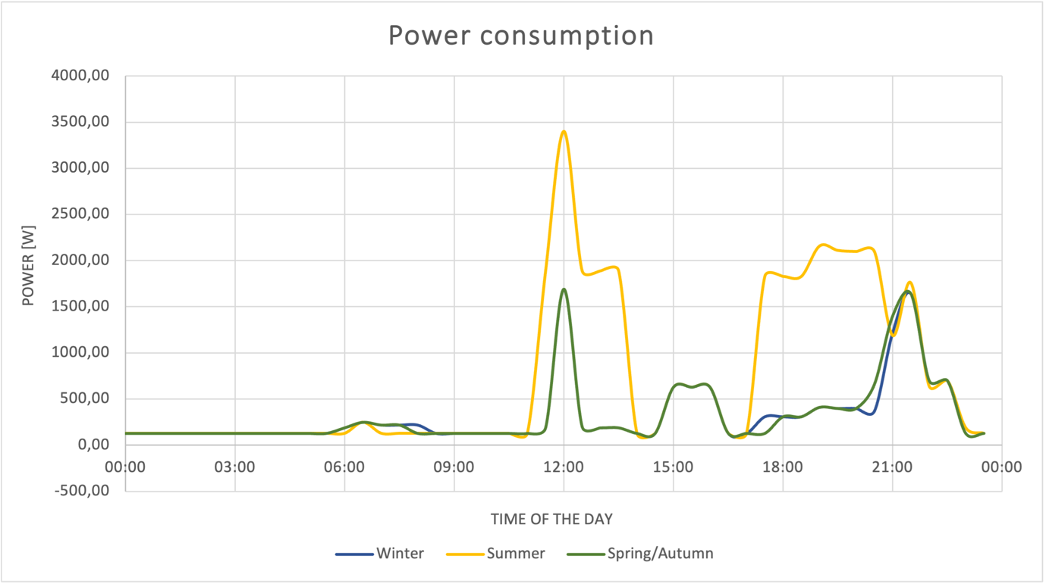

The chart above shows the electrical loads daily profiles for the different seasons.  
Since winter and spring/autumn have almost identical schedules, differences between the two are related only to the external lights being inactive in winter and an extra 30 minutes in both lights and TVs. Summer differs from the other two seasons for the heavy use of air conditioning around lunch and dinner times, while TV and lights change as mentioned above.

Power wise, the peak demand is equal to $3567 W$ and takes place in the summer, at noon, when both the AC and the oven are in operation. In the evening, around 21:30, an additional, smaller, peak of demand happens when the vacuum cleaner is used, unrelated to the season.

The energy consumption follows the behavior of the power: the average daily energy consumptions are found to be equal to 7.632 kWh, 17.487 kWh and 7.732 kWh for winter, summer and spring/autumn respectively.  
Additionally, average seasonal consumptions have been calculated and they are equal to 246.34 kWh in winter, 538.19 kWh in summer and 237.75 kWh in spring and autumn.

# 

# Plant Design

## System components

### PV Panels

The PV panel chosen for the preliminary design is the *AE550MD-144* from *AE Solar.*The panel has been chosen from a list of products, manufactured in Iran or imported, due to its performance and overall characteristics that are reported below and in the referenced datasheet [1].  
The *AE550MD-144* has an expected lifetime of 30 years, with a relative guaranteed power of $81.55\%$ in the last year of operations.

|  |  |  |
| --- | --- | --- |
| **Mechanical and design specifications** | | |
| Height | $$2278$$ | mm |
| Length | $$1133$$ | mm |
| Thickness | $$30$$ | mm |
| Weight | $$26,5$$ | kg |
| No. of cells | $$144$$ |  |

Table 4: *Mechanical and design specifications*

|  |  |  |
| --- | --- | --- |
| **Electrical specifications** | | |
| Nominal max Power | $$414$$ | $$W$$ |
| Maximum operating voltage | $$40,1$$ | $$V$$ |
| Maximum operating current | $$10,34$$ | $$A$$ |
| Open-circuit voltage | $$47,8$$ | $$V$$ |
| Short-circuit voltage | $$10,94$$ | $$A$$ |

Table 5: *Electrical specifications at Normal Module Operating Temperature (NOMT)*

### A white electronic device with buttons Description automatically generatedInverter

Two different types of inverters can be used for off-grid applications in households: off-grid inverters and hybrid inverters, with the latter combining solar and battery inverters in a single unit and providing more flexibility and lower ohmic losses compared to the former.

For our application we chose the *Sunny Tripower Smart Energy* hybrid inverter, as it has operating ranges suited for the household’s power demand and overall high-end characteristics that makes it one of the best options on the markets. Technical data is reported in the datasheet[2].  
The specific model, in terms of rated output, is chosen out of the four possible to match the PV field’s number of panels and its configuration.  
As the warranty expires after 10 years, we will consider the lifespan of the inverter to be that long and each unit used will be replaced every 10 years of operations, which means that three different inverters of the same model will be used over the 30 years of expected lifetime.

Figure 2: *SMA Sunny Tripower Smart Energy hybrid inverter*

Battery

The battery that will be installed, taken from the list of compatible batteries given in the inverter’s datasheet, is the *Battery-Box Premium HVS/HVM.* It is a Cobalt free Lithium Iron Phosphate (LFP) battery with a modular design and two different High Voltage Small or Medium (*HVS/HVM)* possible configurations: one *Battery-Box Premium HVS* is composed of 2 to 5 HVS battery modules that are connected in series to achieve a usable capacity of 5.1 to 12.8 kWh, while a *Battery-Box Premium HVM* is composed of 3 to 8 HVM battery modules connected in series to achieve a usable capacity of 8.3 to 22.1 kWh. Up to three batteries of the same type (*HVS/HVM*) can be added in parallel to achieve a capacity up to 66.3 kWh with three HVM batteries of 22.1 kWh capacity.  
Following the same logic used for the inverters, each battery will be replaced every 10 years of operations.  
To simulate a behavior as realistic as possible, charge and discharge efficiencies of the battery have been taken into account and their assumed to be equal to $0.95$ and $0.9$ respectively. These values are assumed considering what reported in the “*On the Efficiency of LFP Lithium-ion Batteries*”[3] paper and accounting for the devices decay.

As for the inverter, the specific design of the battery (number and type of modules) will be chosen, depending on the design adopted, to fulfill the need of the household on a yearly analysis.  
  
All the technical data for each of the possible configurations is provided in the datasheet[4].

## Design analysis

As already reported, the southern pitch of the roof is $15 m$ wide, $1 m$ high and $7.5 m$ long on the horizontal and $7.56 m$ diagonally, with the total available area equal to $113.495 m^{2}$.

Since the panels are mounted on a tilted roof there is no mutual shading between the panels and no other elements such as trees or tall buildings shade the southern pitch of the roof.

As a preliminary evaluation, we tried to identify if it would be better to adopt a portrait or a landscape orientation for the panels, choosing the one that allows to install the higher amount of panels.  
If the panels were to be mounted landscape, that would allow to install 36 panels is a $6×6$ configuration, while the portrait orientation would allow a $3×13$ configuration, with a total of 39 panels installed considering the total available area on the pitch (no space in between the single panels). The portrait configuration would then be the better one, allowing for a higher peak capacity of $16.146 kW,$ calculated at *NOMT*, assuming the distances of $13.55 cm$ from the sides and $36.62 cm$ from the top and bottom edges to be acceptable.  
If instead a minimum distance of $30 cm$ from the lateral edges were to be required, both configurations would allow a maximum of $36$ panels to be installed (landscape is still $6×6$, portrait changes to a $3×12$ configuration), leaving plenty of room for possible spacing between panels for the cables. In this case the peak power production would be of $14.904 kW$.  
Considering the location of the building, there is no need to adopt the landscape configuration to be able to easily get rid of eventual snow layers, so any of the two configurations can be chosen.

### Methodology adopted for the design optimization

The optimal plant design is the one to which corresponds the minimum *Levelized Cost of Electricity (LCOE)*. Since the *Levelized Cost of Electricity* is a function of the capital and operating expenditures, the PV field and the Battery Energy Storage System (*BESS)* are sized so that the LCOE is minimized.

The optimal configuration of the stand-alone PV plant with battery energy storage is found following a few steps.

As a first design we considered the one that allows to install the maximum number of panels on the rooftop, that is 36 panels, meaning that the starting DC size is the maximum that is physically allowed. To the maximum possible rated output corresponds the battery that allows to cover the loads during the whole year with the smallest capacity. As the DC size decreases, and so does the power output, a bigger battery will be required.  
Since the panels are initially installed in a $3×12$, each of the different design analysed will have one string of 3 panels less than the previous one until the chosen DC size would no longer be able to cover the loads even with a battery of infinite capacity.

The inverter is chosen between the four possible models of the *Sunny Tripower Smart Energy* hybrid inverter, that are reported in the datasheet, so that it matches the chosen PV field design. For example, considering 36 panels, two *Sunny Tripower 8.0 Smart Energy* units are required, with an $8000 W_{AC}$ rated output, and the panels are arranged in $4 strings of 9 panels in series$ in order to match the inverter’s requirements. The inverter model and number of units may change depending on the configuration adopted for the PV field.  
Inverters also account for self-consumptions, as a single inverter has a load equal to $44 W$.

The battery capacity required to cover the loads during the year is then calculated, based on the annual hourly PV production data taken from *PVSyst*, so that each of the three batteries used during the 30 years of operation at their last year, which corresponds to $\sim 80\%$ of the initial battery capacity, are able to cover the loads considering also that the PV panels’ performance lowers with the years with the trend reported in the datasheet[1].  
For example, the battery bought at year 21 has to be able to cover the loads at year 30 considering that the panels produce around $\sim 81.55\%$ of the nominal power of $550 W per panel$.  
From a practical point of view, we found the capacity required to cover the loads at the 10th, 20th and 30th year and then increased said capacity by $25\%$.

The LCOE is then computed as

$$LCOE = \frac{CAPEX+ \sum_{i}^{30}{({OPEX}_{i}} × \frac{{(1+inflation)}^{n-1}}{{(1+discount)}^{n-1}})}{\sum_{i}^{30}{{Annual electricity consumption}_{i}}}$$

where $CAPEX$ and $OPEX$ are the capital and operating expenditures respectively, while $inflation$ and $discount$ are the inflation and discount rates, assumed equal to 3% and 7.2% respectively. $CAPEX$ 
 and $OPEX$ components will be reported in detail with the results of the analysis.

### 

### BESS Operating Strategy

The operating strategy adopted for the BESS charging and discharging is here reported.  
The battery capacity (BESS) is considered in $\left[kWh\right]$ in the following equations.

**Case 1**:

$${Energy produced}_{hour i}>{Energy consumed}_{hour i}$$

When there is a surplus of energy, it is possible to charge the battery. If the battery where to be already at a *State of Charge (SoC)* of 100%, or it would be reached with just a share of the energy surplus, the extra energy is lost. This last condition is checked considering:

$${SoC}_{hour i-1}<BESS- η_{charge}×(E_{{produced}_{hour i-1}}-E_{{consumed}_{hour i-1}})$$

The check is done considering the SoC, that is here and in the following equations taken in $\left[kWh\right]$ and not as a percentage of the battery capacity, and the production and consumption values at the previous hour. If the condition is not respected, SoC stays at 100% and the extra power is lost, while if true the battery is charged:

$${SoC}_{hour i}= {SoC}_{hour i-1}+ η_{charge}×(E_{{produced}_{hour i-1}}-E_{{consumed}_{hour i-1}})$$

while the lost energy would be calculated as:

$${Energy lost}_{hour i}= \left[{SoC}_{hour i}+(E_{{produced}_{hour i}}-E_{{consumed}_{hour i}})\right]-BESS$$

**Case 2**:

If instead the power supplied in the $hour i$ by the PV field were to be lower than the demand at the same time:

$${Energy produced}_{hour i}<{Energy consumed}_{hour i}$$

The battery would have to be discharged to cover the remaining share of the demand and the *State of Charge* at the considered $hour i$ would be:

$${SoC}_{hour i}= {SoC}_{hour i-1}-\frac{\left|E_{{produced}_{hour i-1}}-E_{{consumed}_{hour i-1}}\right|}{η_{discharge}}$$

The battery capacity is calculated iteratively, considering increasing capacities so that there are no negative values of *State of Charge*, that would be physically impossible and meaningless, for each hour of the years of operations of each of the three batteries adopted per PV field configuration.

### Results

For each of the designs analysed the main results are here reported.

|  |  |  |  |  |  |
| --- | --- | --- | --- | --- | --- |
| PV Panels | Rated Power [kW] | BESS 1 [kWh] | BESS 2 [kWh] | BESS 3 [kWh] | Equivalent hours |
| 36 | 19,8 | 17,5 | 17,625 | 17,875 | 1273,98 |
| 33 | 18,15 | 18 | 18,125 | 18,25 | 1269,41 |
| 30 | 16,5 | 18,25 | 18,375 | 18,625 | 1265,81 |
| 27 | 14,85 | 18,625 | 18,75 | 19,375 | 1261,62 |
| 24 | 13,2 | 19,625 | 21,75 | 24 | 1254,48 |
| 21 | 11,55 | 24,625 | 26,5 | 28,375 | 1247,02 |
| 18 | 9,9 | 23,75 | 25,375 | 27 | 1273,98 |
| 15 | 8,25 | 29 | 30,375 | 31,75 | 1264,98 |
| ~~12~~ | ~~6,6~~ | 40 | 65,625 | ~~84,75~~ |  |
| ~~9~~ | ~~4,95~~ | ~~too high~~ | ~~too high~~ | ~~too high~~ |  |
| ~~8~~ | ~~4,4~~ | ~~too high~~ | ~~too high~~ | ~~too high~~ |  |
| ~~6~~ | ~~3,3~~ | ~~too high~~ | ~~too high~~ | ~~too high~~ |  |

Table 6: *Battery sizing and equivalent hours*

In the table above, for each of the DC sizes considered are reported:

* the corresponding rated power output, computed as $number of modules × 550 W$;
* the required capacity for the batteries that are purchased and start their operations at year 1, 11 and 21 respectively so that they cover the loads of their respective last year of operations;
* the number of equivalent hours, computed as $h_{eq}= \frac{annual electricity production}{rated power}$ in nominal conditions.

It is important to note that for the 12 panels configuration the BESS capacity required to cover the loads in the last 10 years of operations, accounting for battery’s and panels’ decays, would be greater than the maximum possible capacity that can be obtained combining the highest capacity modules in parallel. As the batteries required for the cases with even less panels would be even higher, those configurations have not been considered going on with the optimization analysis.

|  |  |  |  |  |
| --- | --- | --- | --- | --- |
| PV Panels | DC size [kW] | CAPEX [€] | OPEX [€] | LCOE [€/kWh] |
| 36 | 19,8 | 26669 | 66032 | 0,424551 |
| 33 | 18,15 | 25943,75 | 62732 | 0,408777 |
| 30 | 16,5 | 24762,5 | 60020 | 0,39057 |
| 27 | 14,85 | 23581,25 | 57461 | 0,372794 |
| 24 | 13,2 | 24509 | 59507 | 0,386857 |
| 21 | 11,55 | 25488,75 | 63503 | 0,406868 |
| 18 | 9,9 | 23411,5 | 56004 | 0,367177 |
| 15 | 8,25 | 25723,25 | 58771 | 0,395666 |

Table 7: *Economic parameters*

**Table 7** reports the most important economic parameters, whose definitions have already been given, while a CAPEX and OPEX breakdown is given in **Table 8** and **Table 9** respectively.

|  |  |  |  |  |  |  |  |  |
| --- | --- | --- | --- | --- | --- | --- | --- | --- |
| PV Panels | Installation costs [€] | Modules cost [€] | Inverters | Inverters cost [€] | 1st battery capacity [kWh] | Batteries cost [€] | Cables cost [€] | **CAPEX** [€] |
| 36 | 2871 | 5832 | 2 x 8 kW | 5504 | 19,3 | 11462 | 1000 | 26669 |
| 33 | 2631,75 | 5346 | 2 x 8 kW | 5504 | 19,3 | 11462 | 1000 | 25943,75 |
| 30 | 2392,5 | 4860 | 1 x 8 kW 1 x 6 kW | 5048 | 19,3 | 11462 | 1000 | 24762,5 |
| 27 | 2153,25 | 4374 | 2 x 6 kW | 4592 | 19,3 | 11462 | 1000 | 23581,25 |
| 24 | 1914 | 3888 | 2 x 6 kW | 4592 | 22,1 | 13115 | 1000 | 24509 |
| 21 | 1674,75 | 3402 | 2 x 5 kW | 4104 | 11+13,8 | 15308 | 1000 | 25488,75 |
| 18 | 1435,5 | 2916 | 1 x 8 kW | 2752 | 11+13,8 | 15308 | 1000 | 23411,5 |
| 15 | 1196,25 | 2430 | 1 x 8 kW | 2752 | 11+19,3 | 18345 | 1000 | 25723,25 |

Table 8: *CAPEX breakdown*

For each design the *Capital Expenditures (CAPEX)* is the sum of:

* the cost of purchasing the modules, calculated as $price per panel\left[\frac{€}{unit}\right]×number of panels$, where the price per panel is equal to [5];
* the cost of installation for the chosen number of PV modules, equal to $installation cost\left[\frac{€}{W}\right]×number of panels×550W$, with the installation cost being equal to [6];
* the cost of the inverters bought at the time of installation of the PV field, that is $\sum{price of inverter i \left[\frac{€}{unit}\right]×number of inverters i}$;
* the cost of the battery or batteries, depending on the required capacity, bought at the time of installation, computed as $\sum{price of battery i \left[\frac{€}{unit}\right]×number of batteries i}$;
* the cost of the cables, that has been taken equal to $1000 €$ as a first hypothesis for each configuration since it doesn’t have a big impact on the results compared to the other cost components. The actual cost will be evaluated in the following detailed design analysis.

The OPEX is instead calculated as the sum of:

* the yearly maintenance and general operation related to the PV modules, that are calculated as $modules inspection cost \left[€\right]+modules cleaning \left[\frac{€}{unit}\right]×number of modules$, with the inspection and cleaning costs being equal to $350 [€]$ and $20 \left[\frac{€}{unit}\right]$ respectively[7];
* the cost of substitutions of the inverters and batteries, that are calculated as the batteries and inverters costs in the CAPEX and happen twice over the 30 years of lifetime of the system.

|  |  |  |  |  |  |  |
| --- | --- | --- | --- | --- | --- | --- |
| PV Panels | 2nd battery capacity [kWh] | 3rd battery capacity [kWh] | Inverters substitutions [€] | Batteries substitutions [€] | PV O&M [€] | **OPEX** [€] |
| 36 | 19,3 | 19,3 | 11008 | 22924 | 1070 | 66032 |
| 33 | 19,3 | 19,3 | 11008 | 22924 | 960 | 62732 |
| 30 | 19,3 | 19,3 | 10096 | 22924 | 900 | 60020 |
| 27 | 19,3 | 22,1 | 9184 | 24577 | 790 | 57461 |
| 24 | 22,1 | 11+13,8 | 9184 | 28423 | 730 | 59507 |
| 21 | 13,8+13,8 | 11+19,3 | 8208 | 35195 | 670 | 63503 |
| 18 | 13,8+13,8 | 13,8+13,8 | 5504 | 33700 | 560 | 56004 |
| 15 | 22,1+8,3 | 19,3+13,8 | 5504 | 38267 | 500 | 58771 |

Table 9: *OPEX breakdown*

As shown in **Table 7** to the minimum Levelized Cost of Electricity corresponds a design with a DC size of **18 panels**, for a total of $9900 W$ of rated output, a single *Sunny Tripower 8.0 Smart Energy* hybrid inverter and a BESS capacity equal to **24.8 kWh** for the 1st battery, obtained combining batteries with capacities of 11 kWh and 13.8 kWh in parallel, and 27.6 kWh for the 2nd and 3rd batteries made up of two *HVM 13.8* by 13.8 kWh in parallel.  
To this configuration corresponds a Levelized Cost of Electricity equal to $0.367 [\frac{€}{kWh}]$.

The following chart shows the trends of 1st BESS capacity and LCOE with respect to the configuration’s DC size.

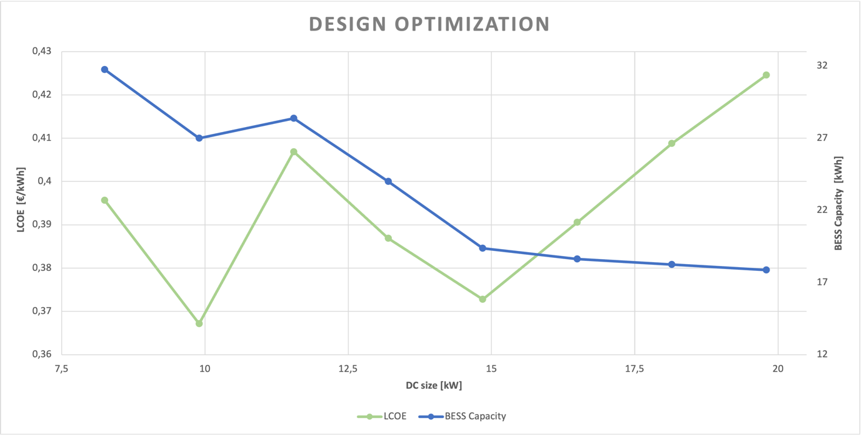

Chart 2: *Design Optimization*

As mentioned above, the minimum is achieved in correspondence of 18 panels and a rated output of $9.9 kW$, with the 27-panel configuration being a close second best.

It also stands out how the capacity required and, consequently the LCOE, increases for the 21 panels configuration, in contrast with the behavior predicted earlier: this is due to the said design being the one with the lowest number of panels that requires two inverter units, to which corresponds a load of 44 W per unit. As the number of panels and the energy produced decrease, that extra load is heavier for the 21-panel configuration than for the designs with bigger DC sizes.

### Most critical week performance

The performance of the stand-alone PV plant with battery during the most critical week over its lifetime is shown in the following chart, where energy consumption, energy production and the battery’s *State of Charge* behaviour throughout the week are plotted.

The most critical week of operation is the week between 25th October 2043 and 31st October 2043, where production is the lowest over the 30 years of lifetime due to the panel’s decay.  
The battery’s decay is taken into account when buying the new components at year 21.

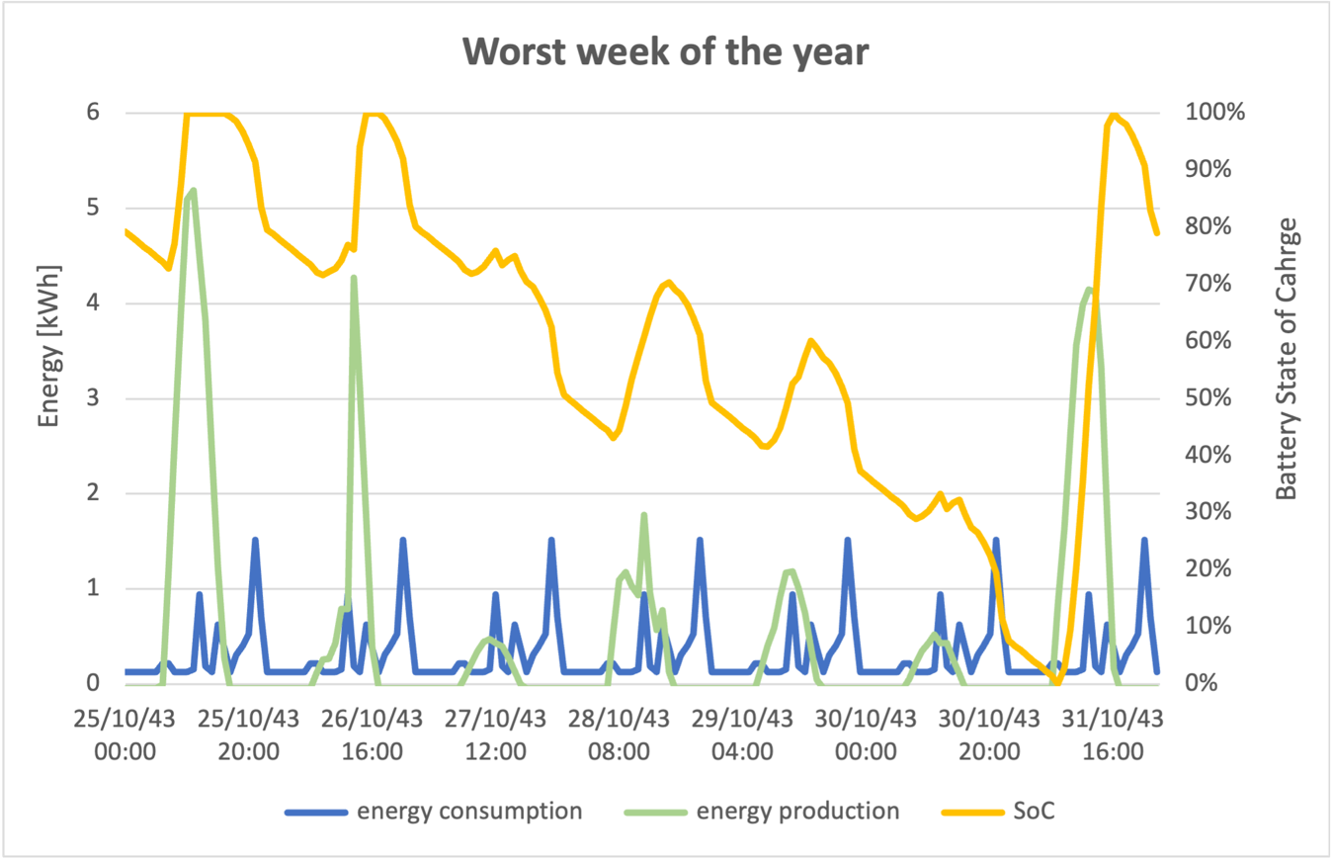

Chart 3: *Most critical week summary*

The chart shows that the battery reaches a SoC equal to 1 just three times over the course of the week, in correspondence of the only three production spikes, one of which happens just after the battery is almost fully discharged and reaches the lowest *State of Charge* of the whole 30 years of operations.  
Additionally, it can be seen that there are times when the production is negative: this happens because the inverter’s self-consumption is account for by deducing the consumption per unit from the energy produced by the PV field and not as a baseload appliance, therefore when there is no contribution of energy from the sun the production is virtually negative.

## Detailed design of the optimal configuration

The components’ sizing has been done for cables, fuses and surge protection devices (SPD) on the DC size and for cables, circuit breakers (switches) and SPD on the AC size.

### DC side

On the DC side the flowing current is calculated as

$$I_{DC,max}=1.25∙I_{SC}∙N_{string}=34 A$$

Where 1.25 is the safety factor, $I_{SC}$ the short circuit current, provided by the manufacturer, and $N_{s}$ is the number of strings adopted. As the number of strings is equal to 2, each will have a max current of $17 A$.

Each string is protected by a fuse, with a maximum DC current flowing through it of $I_{fuse, max}=25 A$, as reported by the manufacturer in the PV panel datasheet. For this reason, a fuse with a rated current of $20 A$ has been selected as the protection device, in particular the *NS20, 20A 440V AC BS88 FUSE* is the one adopted[8].

The cables must be chosen with a rated current higher than that of the fuses. A possible solution would be the *FG21M21 $(2 × 2.5 {mm}^{2})$,* that has a rated current of $40 A$ which provides more than enough gap for the protection of the cable [9].

A surge protection device of rated voltage equal to 1000 V was selected, as the maximum string voltage is $V_{string,max}={1.25∙V}_{OC}∙N_{strings}=578.7 V$.  
The selected model is *HAGSPV325*, manufactured by *Hager*[10].

### AC side

The AC side is sized just like the DC side.

The rated current of the protection devices, the switches, must be greater than the inverter rated current, equal to $I_{inv}=14.45 A$ considering a triphase system, so switches with a rated current of $20 A$ have been chosen. The *BA-2RV22* by *Honeywell* would be a possible solution[11].

As for the DC side, the cables must have a rated current greater than that of the switches, so the common model *FG16OM16 $(3 cores × 2.5 {mm}^{2})$*  was chosen, with a rated current of [12].

The SPD for the AC size chosen is the *HAGSPA201,* with a rated voltage of 255 V [10].

The prices for the selected cables have been found to be equal to $1.78\frac{€}{m}$ and $2.51\frac{€}{m}$ for the DC side[13] and AC side[14] cables respectively.  
Due to the location of the electric box, that would be placed in the attic of the building, the DC and AC cables would be 30 m per string and 20 m long respectively, accounting for a total of $157 €$.

With said cost of cables, the updated Levelized Cost of Electricity of the optimal design would be equal to .

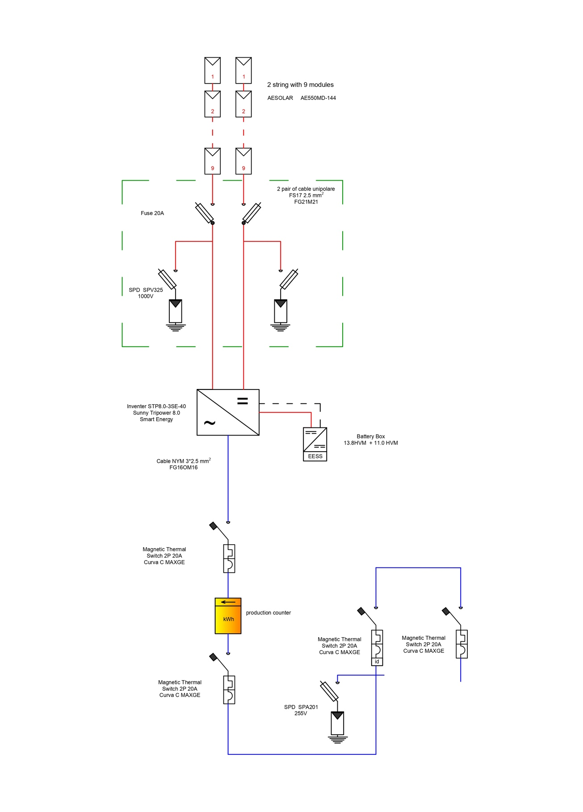

Figure 3: *Schematic representation of the circuit*

### Inverter matching

The model and number of inverters installed is determined through PVSyst, that automatically matches inverters and PV field considering the voltage and current constraints as well as the impact of temperature and irradiance on the performance of the modules with the following criterias.

The number of inverters adopted can be chosen on the base of the $DC/AC$ ratio of the inverter, that is the ratio between the DC power coming from the PV field and the total AC power from the inverters. For the optimal design, for example, with $18 panels$ and $9.9 {kW}_{DC}$ and a single *Sunny Tripower 8.0 Smart Energy* hybrid inverter, that has an $8 {kW}_{AC}$ rated output, the $DC/AC$ ratio would be equal to $1.238$, that is a good ratio.

The calculations regarding the current and voltage constraints are done taking into account how the performance of the PV field varies with ambient conditions, considering the maximum and minimum ambient temperature, respectively $+40.5°C$ and $-3.5°C$ in the considered location, to which correspond the maximum and minimum operating temperatures of the cell.

$$T_{cell,max/min}=T_{amb, max/min}+ \frac{NOCT-T_{amb,NOCT}}{G_{NOCT}}∙G=51.11°C/7.19°C$$

where $G$ is the average irradiance in $[\frac{W}{m^{2}}]$ as computed from the TMY data for the selected location.

Current, voltage and power coefficients are given from the manufacturer in the PV panel’s datasheet (⍺, β and ɣ respectively, expressed in $[\%/{°C}]$) to convert the values of interest from STC to real operating conditions.

To ensure efficient operations of the system and a correct matching with the inverter, it

is necessary to evaluate the number of modules that can be connected in a string considering the worst-case operating conditions, that are the lowest and highest temperatures the modules will experience.   
In terms of voltage this occurs when the temperature of the modules is at its lowest recorded.

All the data need to check the constraints are given in the inverter[2] and panel[1] datasheets.

$$V_{OC}=V_{OC,STC}∙\left(1+β∙\left(T_{cell,min}-T_{cell,STC}\right)\right)=53.96 V$$

$$V_{MPP}= V_{MPP,STC}+V_{OC,STC}∙β∙\left(T_{cell,max/min}-T_{cell,STC}\right)$$

$V_{MPP,Tmax,mod}=38.88 V$ $V_{MPP,Tmin,mod}=45.09 V$

$$N_{mod,string}<\frac{V_{MPPT,max,inv}}{V_{MPP,Tmin,mod}}=17.74$$

$$N_{mod,string}>\frac{V_{MPPT,min,inv}}{V_{MPP,Tmax,mod}}=8.49$$

$N_{mod,string}<\frac{V_{OC,max,inv}}{V_{OC,Tmin,mod}}=$ 18.53

The actual maximum number of modules per string is the minimum between the two found, as both constraints must be respected.

To calculate the maximum number of the strings that can be connected in parallel to each

inverter, the worst conditions in terms of current, that is when the cell temperature is at its highest has been considered.

$$I_{SC}=I_{SC,STC}∙\left(1+⍺∙\left(T_{cell,max}-T_{cell,STC}\right)\right)=13.83 A$$

$$I_{MPP}=I_{MPP,STC}+I_{SC,STC}∙⍺∙\left(T_{cell,max}-T_{cell,STC}\right))=13.08 A$$

$$N_{string,MPPT}<\frac{I_{MPPT,max,inv}}{I_{MPP,Tmax,mod}}=0.868$$

$$N_{string,MPPT}<\frac{I_{SC,max,inv}}{I_{SC,Tmax,mod}}=1.45$$

The optimal design features a single $8 {kW}_{AC}$ inverter with two MPPTs, each with a single string of 9 panels in series, for a total of 18 panels.

While all the constraints on the voltage and the one regarding the short-circuit current are fulfilled, a max MPPT current from the module higher than the maximum usable input current of the inverter is acceptable, as the only consequence is that clipping will occur with high irradiance.

### Battery – Inverter matching

When matching batteries and inverters two key factors are considered:

1. the battery’s nominal voltage must be within the range of allowed batteries specified in the inverter’s datasheet;
2. the maximum charge/discharge current is the minimum charge/discharge current between that of the battery and that of the inverter. This allows to determine the maximum power that can be sent to or withdrawn from the battery on a yearly analysis.

The batteries considered were taken from a list of batteries compatible given by the *Sunny Tripower 8.0 Smart Energy* hybrid inverter manufacturer [15].

# Life Cycle Assessment

The *Life Cycle Assessment* (LCA) of electricity generation projects is an essential stage of the planning process to evaluate their environmental impact. LCA examines the inputs and outputs of a project during its full lifecycle, from planning to decommissioning, and is used to formulate energy policy and make decisions about research and development (R&D) funding.

LCA is a valuable tool for PV system optimization based on a range of environmental variables. It also provides a means to directly compare different types of energy technologies, demonstrating how investing in a PV system compares with other forms of electricity generation.

The useful life of a PV system is estimated to be on average of 25 to 40 years, depending on factors such as the equipment used and environmental conditions. LCA of a PV system looks at the impact on the environment from the production of equipment through to the disposal of the panels. The lifecycle stages of photovoltaics involve:

* raw materials extraction, processing and refining;
* manufacturing of PV modules and other system components;
* installation;
* system operation and maintenance;
* plant decommissioning and disposal or recycling .

Since our plant is a stand-alone PV plant with battery energy storage, the carbon footprint of both the PV field and the Battery Energy Storage System have to be taken into account.

### PV field’s carbon footprint

Manufacturing photovoltaics is the most energy intensive step of installed PV modules, as large amounts of energy are used to convert silica sand into the high purity silicon required for photovoltaic wafers.

The environmental impact of a silicon photovoltaic module involves the production of three main components: the frame, the module, and balance-of-system components such as the rack and inverter, with greenhouse gases caused mostly by module production (81%), followed by the balance of system (12%) and frame (7%).

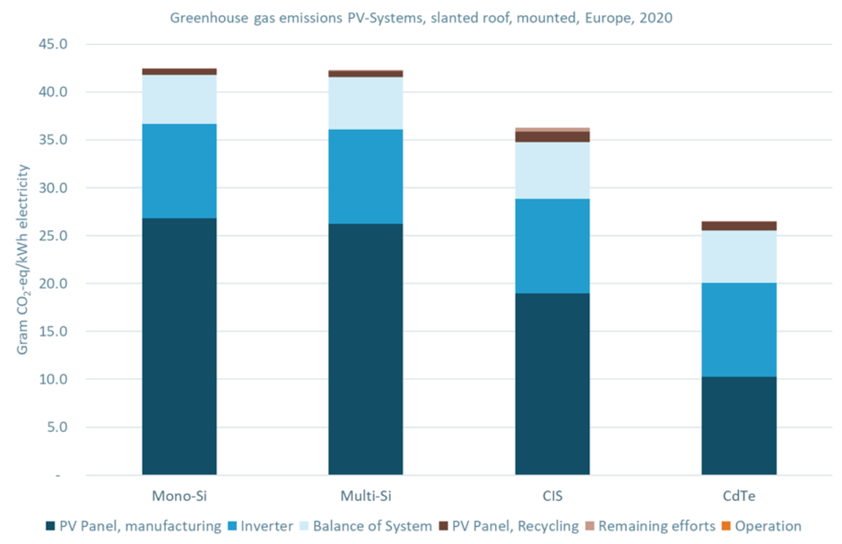

Figure 4: *Greenhouse gas emissions for different panel technologies*

There is little to no impact from operations and end-of-life activities, in direct contrast to fossil and nuclear power plants which release the majority of their emissions through their ongoing operations and fuel supply.

The panels adopted for the plant are *AE550MD-144,* mono-crystalline PV modules made of *Gallium-doped Mono c-Si PERC* half-cut cells. Lifecycles greenhouse gas emissions of this panel technology are reported [16][17] to have a carbon intensity of around

$${{ eCO}_{2}}_{PV field}=42.5 ÷45 \frac{g_{{CO}_{2}}}{kWh}$$

Since, as already said, the carbon emissions are related mostly to the manufacturing of the modules, solar panels require around three years of operations to pay off their carbon debt and become then carbon neutral.[18][19]

### Battery Energy Storage System’s carbon footprint

As for the PV field, the carbon footprint of the battery storage system is strongly dependant on the technology adopted and it can be split in the production, use and end-of-life phases.

The batteries chosen for our application are Lithium Iron Phosphate (LFP) batteries.

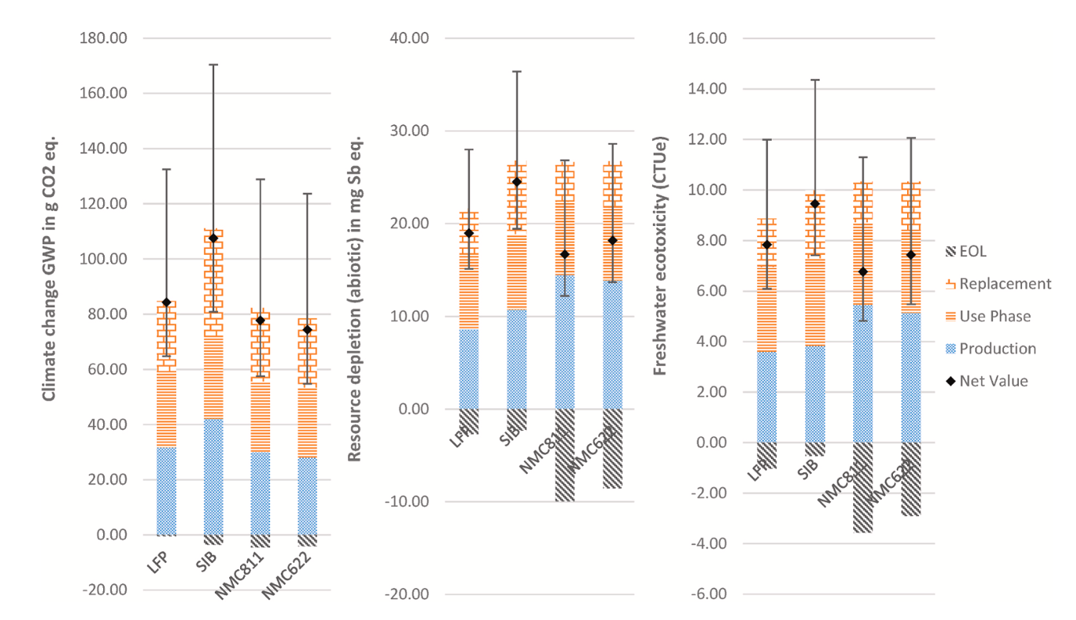

**Figure 5:** *Impacts of the full life cycle of a BESS.*

Values given per kWh of energy delivered over lifetime of the HSS (FU). The dot marks the net result corresponding to the numeric value provided above each column, and the error bars indicate the range of possible results when varying the number of cycles per day (2 cycles for lower bound and 0.5 cycles for upper bound).

In contrast with the panels’ footprint, the battery’s use phase turns out to be highly relevant, accounting for the largest share of environmental impacts in most of the cases, driven

mainly by the replacement of battery cells during the lifetime of the BESS.

The net carbon intensity of a LFP battery, accounting for all of the peripheric components of the BESS, is reported [20] equal to

${eCO}_{2_{BESS}}= 84 \frac{g_{{CO}_{2}}}{kWh}$

## Carbon intensity

The carbon intensity of the stand-alone PV plant with energy storage is calculated as the ratio between the total carbon dioxide emissions and the total energy production, expressed in $\frac{g_{{CO}_{2}}}{kWh}$

$$Carbon Intensity= \frac{{CO}_{2_{total}}}{total energy production}= 24.8 \frac{g_{{CO}_{2}}}{kWh}$$

with

$${CO}_{2 total}= {CO}_{2 PV field}+ {CO}_{2 BESS}= 8.19 t_{{CO}_{2}}$$

$${CO}_{2 PV field}= {{eCO}_{2}}_{PV field}× E_{el,first 3 years of operations}= 1.559 t_{{CO}_{2}}$$

$${CO}_{2 BESS}={eCO}_{2_{BESS}}×\left({BESS}_{1}+ {BESS}_{2}+ {BESS}_{3}\right)= 6.631 t_{{CO}_{2}}$$

with ${BESS}_{1}, {BESS}_{2}, {BESS}_{3}$ being the capacities in kWh of the three batteries adopted over the 30 years of lifetime of the plant.

The total energy production (TEP) has been calculated as

$$TEP= \frac{A{EP}_{year 1}}{η_{decay, year 1}} × η_{decay, year 15} × panels lifetime$$

where ${AEP}_{year 1}$ is the energy produced during the first year of operations, lifetime of the panels is equal to 30 year and $η_{decay, i}$ is the percentage of guaranteed power through the years, due to the decay of the panels, provided by the manufacturer in the module’s datasheet, with respect to that of year 1. Since the behaviour of the decay is linear, $η_{year 15}$ is the average value used to compute the TEP over the 30 years of operations.

As of today, there is no *Emission Trading System* (ETS) or Carbon Tax is implemented or scheduled for implementation in Iran [21].

## Life Cycle Emissions

An additional, different analysis for the carbon footprint of the PV field has been carried out using the *Carbon Balance tool* of *PVSyst*.

The Carbon Balance tool allows to estimate the savings in CO2 emissions expected for the PV installation. The basis of these calculations is the *Life Cycle Emissions* (LCE), which represent the emission of CO2 associated with the given components or energy amount for each the phases of the life cycle mentioned in the previous paragraphs.

If the carbon footprint of the PV installation is smaller than the one of the grid electricity productions, both expressed $per kWh$, there is a net saving in CO2 emissions, thus the total carbon balance for the PV installation is the difference between the produced and saved CO2 emissions.

In contrast with the previous analysis, for which an average value of emissions was considered, the LCEs are here estimated via the *Grey Energy*, that is the energy involved in the production of the components, converted into emissions with a specific conversion factor that is a function of the components.

The results of this analysis are reported at the end of the attached *PVSyst* report.

# Conclusions

The aim of this report was the preliminary design and evaluation of the operational and economical performances of a stand-alone PV plant with battery energy storage.

The optimal design of the plant has been obtained by comparing the system investment costs of different PV field configurations in order to identify the combination of inverters, batteries and number of modules that minimizes total costs respecting components constraints.

The design to which corresponds the minimum Levelized Cost of Electricity turned out to be composed of:

* 18 *AE550MD-144* modules;
* one *Sunny Tripower 8.0 Smart Energy* hybrid inverter;
* a battery with 24.8 kWh of capacity for the first 10 years of operations and two batteries each with 27.6 kWh of capacity for the last 20 years of operation, 10 per battery;
* 30 m of *FG21M21* and 20 m of *FG16OM16* cables for the DC and AC side respectively, both with a cross section of $2.5 {mm}^{2}$;
* two *NS20, 20A 440V AC BS88* fuses for the DC side and a *BA-2RV22* by *Honeywell* circuit breakers for the AC side;
* one *HAGSPV325* surge protection device for the DC side and a *HAGSPA201* SPD for the AC side.

To fulfil the demand even during the worst week of performance of the plant, the battery size has been evaluated so that it is able to cover the loads taking into account both the PV modules’ and the batteries’ decay.

The LCOE of the optimal design has been calculated to be equal to $359.14\frac{€}{MWh}$, a value much higher than the average electricity price in Iran.

The main benefit of the installation of the considered plant would be related to environmental aspects, as the PV field and battery storage equivalent emissions are combined less than a third of the average carbon intensity of the country, equal to [21], with low-carbon electricity share of just 6.2% of the country’s overall electricity production.

As the off-grid solution is not strictly needed due to the location of the household, a grid-tied solution with a battery storage to maximize self-consumption would probably lead to a much smaller Levelized Cost of Electricity with even just a small percentage of electricity bought from the grid.

# References

[1] – *AE MD-144 Series 530W-550W* [datasheet](https://ae-solar.com/wp-content/uploads/2023/09/AE_MD-144_530W-550W_202309-1.pdf)

[2] – *Sunny Tripower Smart Energy 5.0/6.0/8.0/10.0* [datasheet](https://files.sma.de/downloads/STPxx-3SE-40-DS-en-20.pdf)

[3] – Eduardo Redondo-Iglesias, Serge Pelissier. “*[On the Eﬀiciency of LFP Lithium-ion Batteries](https://hal.science/hal-04164693/document)*”. 2022 Second International Conference on Sustainable Mobility Applications, Renewables and Technology (SMART), IEEE, Nov 2022, Cassino, Italy. 5p, 10.1109/SMART55236.2022.9990093 . hal-04164693

[4] – BYD *Battery-Box Premium* HVS/HVM [datasheet](https://www.bydbatterybox.com/uploads/downloads/231122_BYD_Battery-Box_Premium_HVS&HVM_Datasheet_V1.8_EN-655eaa1bcd31f.pdf)

[5] - [پنل خورشیدی 550 وات مونو کریستال برند AE SOLAR - هورآیش (hoorayesh.com)](https://hoorayesh.com/product/solar-panel-550w-mono-aesolar/)

[6] - [How Do I Estimate Solar Installation Costs?](https://www.solar.com/learn/how-do-i-estimate-solar-installation-costs/)

[7] - [Solar Panel Inspection Costs](https://www.angi.com/articles/solar-panel-inspection-cost.htm)

[8] - [Scheda tecnica](https://datasheet.eaton.com/datasheet.php?model=NS20&locale=it_IT) - 20A 440V AC BS88 FUSE (eaton.com)

[9] - [Layout 3 (solar-kit.com)](http://www.solar-kit.com/WebRoot/StoreLFR/Shops/62035995/4E88/C82B/CCFD/A529/5975/C0A8/28BC/4CD0/fiche_technique_cable_4_solaire_FG21M21_baldassari.pdf)

[10] - [Guide to Surge Protection Devices.indd (em.co.za)](https://www.em.co.za/site/img/Supplier%20catalogues/Hager/Guide%20to%20Surge%20Protection%20Devices_eB.pdf)

[11] - [HWSCS05094_1-3072096.pdf (mouser.it)](https://www.mouser.it/datasheet/2/187/HWSCS05094_1-3072096.pdf)

[12] - [Layout 2 (baldassaricavi.it)](https://www.baldassaricavi.it/wp-content/uploads/2019/12/22-FG16OM16.pdf)

[13] - [25_05_Pon_Sibari_Allestimenti_Elencoprezzi.pdf (beniculturalicalabria.it)](https://www.beniculturalicalabria.it/echoweb/echofiles/allegati/25_05_Pon_Sibari_Allestimenti_Elencoprezzi.pdf)

[14] - [CPR CAVI FG16OM16-0,6/1KV 3G2,5 guaina verde con giallo verde AL METRO C0614218102 (rfelettrica.com)](https://www.rfelettrica.com/prezzo/IT02435300591/2575638/fg16om16061kv_3g25_guaina_verde_con_giallo_verde_al_metro_c0614218102.html)

[15] - [Technical Information - SUNNY TRIPOWER SMART ENERGY](https://files.sma.de/assets/278870.pdf)

[16] - [LCA of silicon PV panels - Appropedia, the sustainability wiki](https://www.appropedia.org/LCA_of_silicon_PV_panels)

[17] - [V1 Task 12 Life Cycle Assessment Fact Sheet (iea-pvps.org)](https://iea-pvps.org/wp-content/uploads/2021/11/IEA-PVPS-Task12-LCA-PV-electricity-_-Fact-Sheet.pdf)

[18] - [What is the Carbon Footprint of Solar Panels? | Solar.com](https://www.solar.com/learn/what-is-the-carbon-footprint-of-solar-panels/#:~:text=Residential%20solar%20panels%20emit%20around,first%20three%20years%20of%20operation.)

[19] - [Carbon Footprint of Solar Panel Manufacturing | Cool Effect](https://www.cooleffect.org/solar-carbon-footprint#:~:text=Around%2050g%20of%20CO2%20per,of%20coal%2Dpowered%20electricity%20sources)

[20] - [Life cycle assessment (LCA) of a battery home storage system based on primary data - ScienceDirect](https://www.sciencedirect.com/science/article/pii/S0959652622024921)

[21] - [Carbon Tax Basics - Center for Climate and Energy SolutionsCenter for Climate and Energy Solutions (c2es.org)](https://www.c2es.org/content/carbon-tax-basics/)

# List of Figures, Tables and Charts

Figure 1 *Project’s location on the map* 1

Figure 2: *SMA Sunny Tripower Smart Energy hybrid inverter* 5

Figure 3: *Schematic representation of the circuit* 14

Figure 4: *Greenhouse gas emissions for different panel technologies* 17

Figure 5**:** *Impacts of the full life cycle of a BESS.* 18

Table 1: *Site location and rooftop characteristics* 1

Table 2: *Appliances* 2

Table 3: *Appliances schedule* 3

Table 4: *Mechanical and design specifications* 5

Table 5: *Electrical specifications at Normal Module Operating Temperature (NOMT)* 5

Table 6: *Battery sizing and equivalent hours* 9

Table 7: *Economic parameters* 9

Table 8: *CAPEX breakdown* 10

Table 9: *OPEX breakdown* 11

Chart 1: *Seasonal daily consumption curves* 4

Chart 2: *Design Optimization* 11

Chart 3: *Most critical week summary* 12